Transformation of B.C. public schools
October 24, 2011. 11:09 am • Section: Report Card
ShareThis 1 1 0

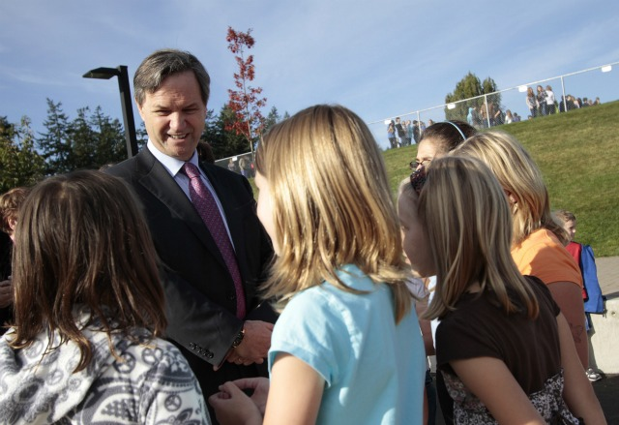Education Minister George Abbott and students, PNG files

BC College of Teachers – collision course?
The Liberal government has been promising significant changes in B.C. schools for a couple of years. Former minister Margaret MacDiarmid started the dialogue but didn’t implement anything of significance. Now George Abbott has picked up where she left off.
Earlier this month, he produced an op-ed titled B.C.’s plan for education transformation. In it, he says he’s been having discussions with students, parents, teachers and other education partners about how to make a good education system great.
“To do that, we need to first acknowledge that every student has their own unique learning style, as well as individual interests and passions, and we need to give them opportunities to achieve their goals,” he wrote.
His plan has five key elements: personalized learning for every student, quality teaching and learning, more flexibility and choice, high standards and learning empowered by technology.
While schools will continue to teach core skills, curriculum will be redesigned to encourage critical thinking and teamwork, and there will be greater recognition of outside activities such as arts, sports, science and leadership programs..
“We will also support families by creating better opportunities for parents to engage in their child’s learning with more flexibility and choice with respect to what, how, when and where their child learns.”
The public will hear more about the plan very shortly, he promises, adding that it will “move education forward, hand-in-hand with teachers, parents, students and all those who share an interest in ensuring our province’s bright future.”
That will be a sight to behold indeed. Find Abbott’s statement from Oct. 13 on the Education Ministry website.

